**OpenCV and Python K-Means Color Clustering**

**<https://www.pyimagesearch.com/2014/05/26/opencv-python-k-means-color-clustering/>**

by [**Adrian Rosebrock**](https://www.pyimagesearch.com/author/adrian/) on May 26, 2014 in [**Image Processing**](https://www.pyimagesearch.com/category/image-processing/), [**Tutorials**](https://www.pyimagesearch.com/category/tutorials/)

[](https://www.pyimagesearch.com/wp-content/uploads/2014/05/jp.png)

Take a second to look at the *Jurassic Park* movie poster above.

What are the *dominant* colors? (i.e. the colors that are represented most in the image)

Well, we see that the background is largely **black**. There is some **red** around the T-Rex. And there is some **yellow** surrounding the actual logo.

It’s pretty simple for the human mind to pick out these colors.

But what if we wanted to create an algorithm to *automatically* pull out these colors?

You might think that a color histogram is your best bet…

But there’s actually a more interesting algorithm we can apply — k-means clustering.

In this blog post I’ll show you how to use OpenCV, Python, and the [k-means clustering algorithm](http://en.wikipedia.org/wiki/K-means_clustering) to find the most dominant colors in an image.

**OpenCV and Python versions:**  
This example will run on**Python 2.7/Python 3.4+** and **OpenCV 2.4.X/OpenCV 3.0+**.

**K-Means Clustering**

So what exactly is k-means?

K-means is a [clustering algorithm](http://en.wikipedia.org/wiki/Cluster_analysis).

The goal is to partition *n* data points into *k* clusters. Each of the *n* data points will be assigned to a cluster with the nearest mean. The mean of each cluster is called its “centroid” or “center”.

Overall, applying k-means yields *k* separate clusters of the original *n* data points. Data points inside a particular cluster are considered to be “more similar” to each other than data points that belong to other clusters.

In our case, we will be clustering the pixel intensities of a RGB image. Given a *MxN* size image, we thus have *MxN* pixels, each consisting of three components: Red, Green, and Blue respectively.

We will treat these *MxN* pixels as our data points and cluster them using k-means.

Pixels that belong to a given cluster will be more similar in color than pixels belonging to a separate cluster.

One caveat of k-means is that we need to specify the number of clusters we want to generate ***ahead of time***. There are algorithms that automatically select the optimal value of *k*, but these algorithms are outside the scope of this post.

**OpenCV and Python K-Means Color Clustering**

Alright, let’s get our hands dirty and cluster pixel intensities using OpenCV, Python, and k-means:

|  |  |
| --- | --- |
| 1  2  3  4  5  6  7  8  9  10  11  12  13  14  15  16  17  18  19  20  21  22  23 | # import the necessary packages  from sklearn.cluster import KMeans  import matplotlib.pyplot as plt  import argparse  import utils  import cv2    # construct the argument parser and parse the arguments  ap = argparse.ArgumentParser()  ap.add\_argument("-i", "--image", required = True, help = "Path to the image")  ap.add\_argument("-c", "--clusters", required = True, type = int,  help = "# of clusters")  args = vars(ap.parse\_args())    # load the image and convert it from BGR to RGB so that  # we can dispaly it with matplotlib  image = cv2.imread(args["image"])  image = cv2.cvtColor(image, cv2.COLOR\_BGR2RGB)    # show our image  plt.figure()  plt.axis("off")  plt.imshow(image) |

**Lines 2-6** handle importing the packages we need. We’ll use the [scikit-learn implementation of k-means](http://scikit-learn.org/stable/modules/generated/sklearn.cluster.KMeans.html" \t "_blank) to make our lives easier — no need to re-implement the wheel, so to speak. We’ll also be using matplotlib to display our images and most dominant colors. To parse command line arguments we will use argparse. The utils package contains two helper functions which I will discuss later. And finally the cv2 package contains our Python bindings to the OpenCV library.

**Lines 9-13** parses our command line arguments. We only require two arguments: --image, which is the path to where our image resides on disk, and --clusters, the number of clusters that we wish to generate.

**On Lines 17-18** we load our image off of disk and then convert it from the BGR to the RGB colorspace. Remember, OpenCV represents images as multi-dimensions NumPy arrays. However, these images are stored in BGR order rather than RGB. To remedy this, we simply using the cv2.cvtColor function.

Finally, we display our image to our screen using matplotlib on **Lines 21-23**.

As I mentioned earlier in this post, our goal is to generate *k* clusters from *n* data points. We will be treating our *MxN* image as our data points.

In order to do this, we need to re-shape our image to be a list of pixels, rather than *MxN*matrix of pixels:

|  |  |
| --- | --- |
| 25  26 | # reshape the image to be a list of pixels  image = image.reshape((image.shape[0] \* image.shape[1], 3)) |

This code should be pretty self-explanatory. We are simply re-shaping our NumPy array to be a list of RGB pixels.

**The 2 lines of code:**

Now that are data points are prepared, we can write these **2 lines of code** using k-means to find the most dominant colors in an image:

|  |  |
| --- | --- |
| 28  29  30 | # cluster the pixel intensities  clt = KMeans(n\_clusters = args["clusters"])  clt.fit(image) |

We are using the [scikit-learn implementation of k-means](http://scikit-learn.org/stable/modules/generated/sklearn.cluster.KMeans.html" \t "_blank) to avoid re-implementing the algorithm. There is also a k-means built into OpenCV, but if you have ever done any type of machine learning in Python before (or if you ever intend to), I suggest using the scikit-learn package.

We instantiate KMeans on **Line 29**, supplying the number of clusters we wish to generate. A call to fit() method on **Line 30** clusters our list of pixels.

That’s all there is to clustering our RGB pixels using Python and k-means.

Scikit-learn takes care of everything for us.

However, in order to display the most dominant colors in the image, we need to define two helper functions.

Let’s open up a new file, utils.py, and define the centroid\_histogram function:

|  |  |
| --- | --- |
| 1  2  3  4  5  6  7  8  9  10  11  12  13  14  15  16 | # import the necessary packages  import numpy as np  import cv2    def centroid\_histogram(clt):  # grab the number of different clusters and create a histogram  # based on the number of pixels assigned to each cluster  numLabels = np.arange(0, len(np.unique(clt.labels\_)) + 1)  (hist, \_) = np.histogram(clt.labels\_, bins = numLabels)    # normalize the histogram, such that it sums to one  hist = hist.astype("float")  hist /= hist.sum()    # return the histogram  return hist |

As you can see, this method takes a single parameter, clt. This is our k-means clustering object that we created in color\_kmeans.py.

The k-means algorithm assigns each pixel in our image to the closest cluster. We grab the number of clusters on **Line 8** and then create a histogram of the number of pixels assigned to each cluster on **Line 9**.

Finally, we normalize the histogram such that it sums to one and return it to the caller on **Lines 12-16**.

In essence, ***all this function is doing is counting the number of pixels that belong to each cluster.***

Now for our second helper function, plot\_colors:

|  |  |
| --- | --- |
| 18  19  20  21  22  23  24  25  26  27  28  29  30  31  32  33  34 | def plot\_colors(hist, centroids):  # initialize the bar chart representing the relative frequency  # of each of the colors  bar = np.zeros((50, 300, 3), dtype = "uint8")  startX = 0    # loop over the percentage of each cluster and the color of  # each cluster  for (percent, color) in zip(hist, centroids):  # plot the relative percentage of each cluster  endX = startX + (percent \* 300)  cv2.rectangle(bar, (int(startX), 0), (int(endX), 50),  color.astype("uint8").tolist(), -1)  startX = endX    # return the bar chart  return bar |

The plot\_colors function requires two parameters: hist, which is the histogram generated from the centroid\_histogram function, and centroids, which is the list of centroids (cluster centers) generated by the k-means algorithm.

On **Line 21** we define a *300×50* pixel rectangle to hold the most dominant colors in the image.

We start looping over the color and percentage contribution on **Line 26** and then draw the percentage the current color contributes to the image on **Line 29**. We then return our color percentage bar to the caller on **Line 34**.

Again, this function performs a very simple task — generates a figure displaying how many pixels were assigned to each cluster based on the output of the centroid\_histogramfunction.

Now that we have our two helper functions defined, we can glue everything together:

|  |  |
| --- | --- |
| 32  33  34  35  36  37  38  39  40  41 | # build a histogram of clusters and then create a figure  # representing the number of pixels labeled to each color  hist = utils.centroid\_histogram(clt)  bar = utils.plot\_colors(hist, clt.cluster\_centers\_)    # show our color bart  plt.figure()  plt.axis("off")  plt.imshow(bar)  plt.show() |

On **Line 34** we count the number of pixels that are assigned to each cluster. And then on **Line 35** we generate the figure that visualizes the number of pixels assigned to each cluster.

**Lines 38-41** then displays our figure.

To execute our script, issue the following command:

|  |  |
| --- | --- |
| 1 | $ python color\_kmeans.py --image images/jp.png --clusters 3 |

If all goes well, you should see something similar to below:

[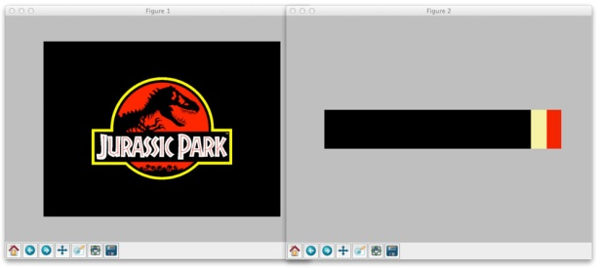](https://www.pyimagesearch.com/wp-content/uploads/2014/05/jurassic-park-colors.jpg)

**Figure 1:** Using Python, OpenCV, and k-means to find the most dominant colors in our image.

Here you can see that our script generated three clusters (since we specified three clusters in the command line argument). The most dominant clusters are black, yellow, and red, which are all heavily represented in the *Jurassic Park* movie poster.

Let’s apply this to a screenshot of *The Matrix*:

[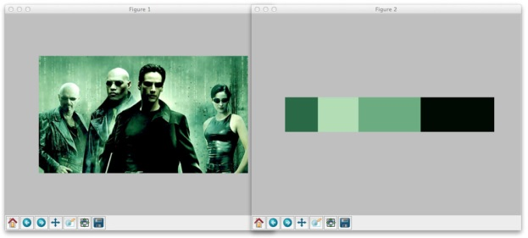](https://www.pyimagesearch.com/wp-content/uploads/2014/05/the-matrix-colors.jpg)

**Figure 2:** Finding the four most dominant colors using k-means in our *The Matrix* image.

This time we told k-means to generate four clusters. As you can see, black and various shades of green are the most dominant colors in the image.

Finally, let’s generate five color clusters for this Batman image:

[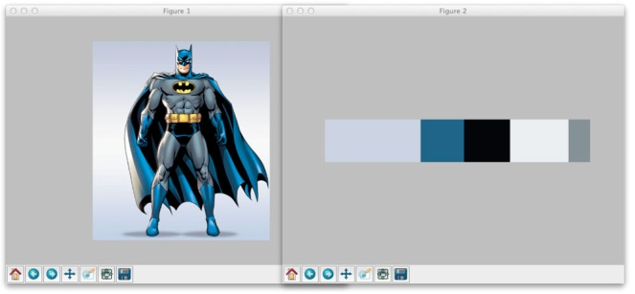](https://www.pyimagesearch.com/wp-content/uploads/2014/05/batman-colors.jpg)

**Figure 3:** Applying OpenCV and k-means clustering to find the five most dominant colors in a RGB image.

So there you have it.

Using OpenCV, Python, and k-means to cluster RGB pixel intensities to find the most dominant colors in the image is actually quite simple. Scikit-learn takes care of all the heavy lifting for us. Most of the code in this post was used to glue all the pieces together.

**Summary**

In this blog post I showed you how to use OpenCV, Python, and k-means to find the most dominant colors in the image.

K-means is a clustering algorithm that generates *k* clusters based on *n* data points. The number of clusters *k* must be specified ahead of time. Although algorithms exist that can find an optimal value of *k*, they are outside the scope of this blog post.

In order to find the most dominant colors in our image, we treated our pixels as the data points and then applied k-means to cluster them.

We used the [scikit-learn implementation of k-means](http://scikit-learn.org/stable/modules/generated/sklearn.cluster.KMeans.html" \t "_blank) to avoid having to re-implement it.

I encourage you to apply k-means clustering to our own images. In general, you’ll find that smaller number of clusters (*k <= 5*) will give the best results.